

Ultrasonic pest repeller
«GRAD А-1000 PRO OPTICAL»

User manual

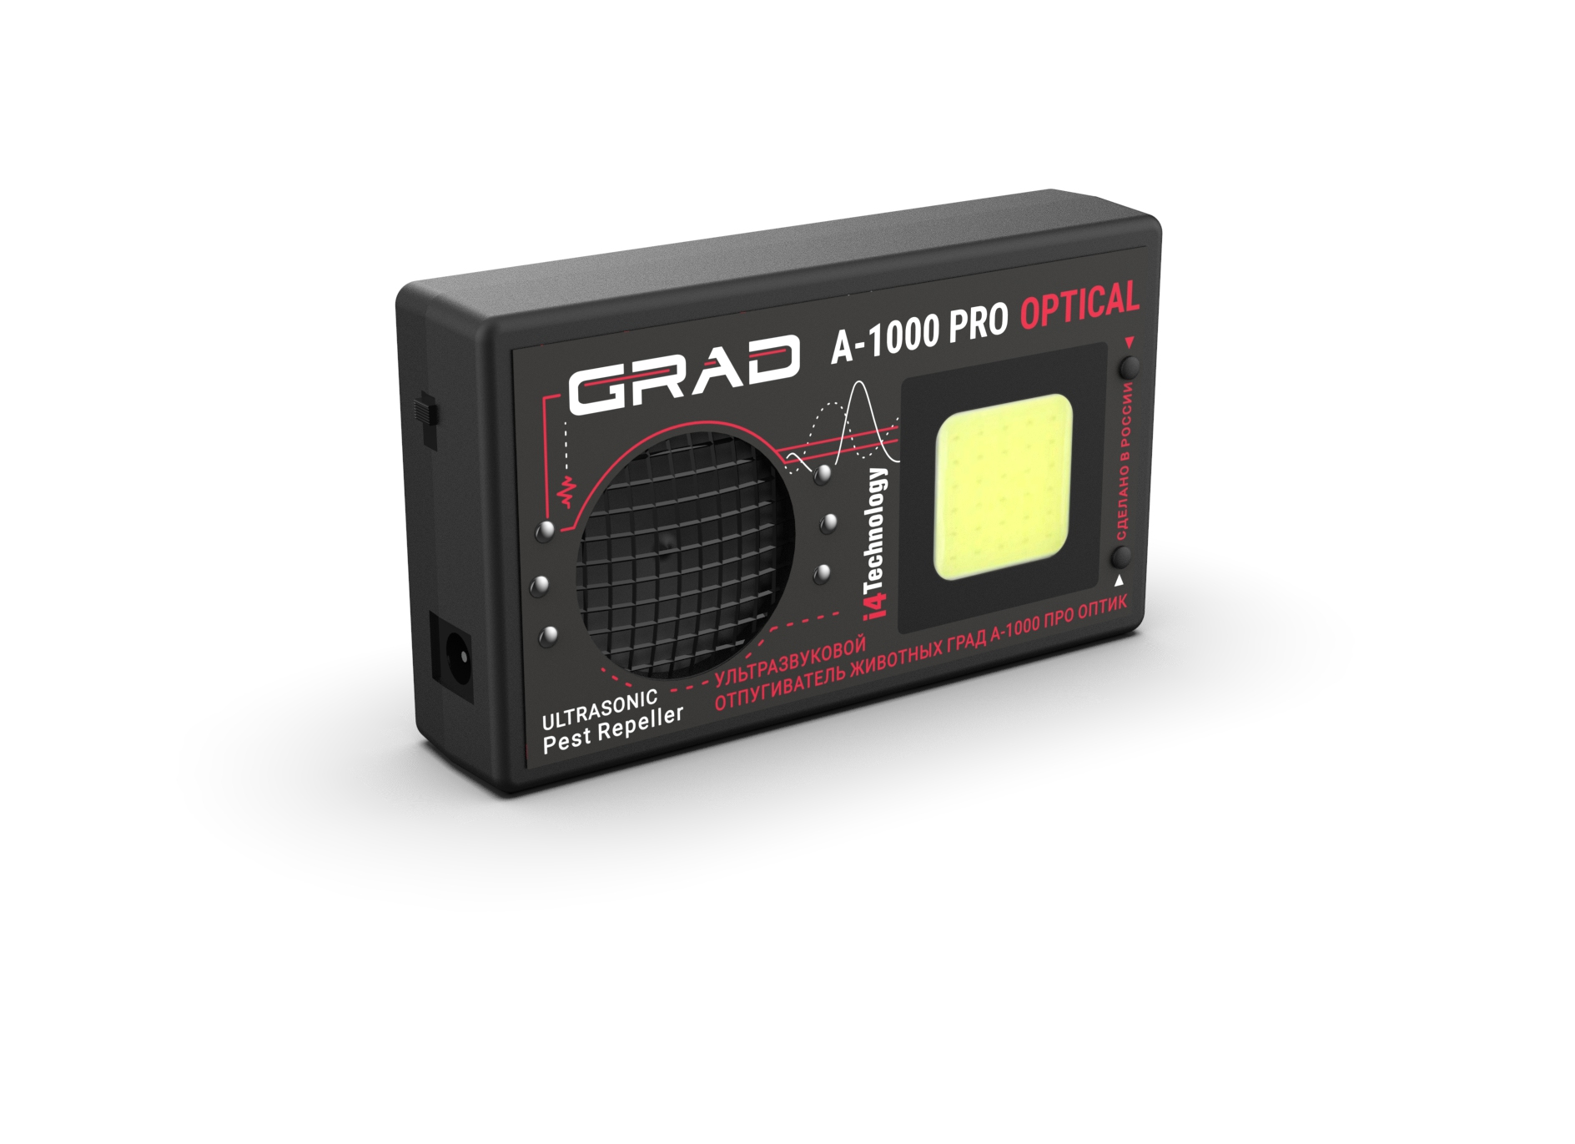

The User Manual includes key features, operating instructions (intended use, maintenance, repair, storage and transportation) of an ultrasonic pest repeller «GRAD А-1000 PRO OPTICAL» (hereinafter – device).
Before using the device, please, carefully read the present User Manual.
Following the instructions, restrictions and guidelines contained in User Manual will extend the life of the device and allow you to use it most effectively.

WARNING! Before using, the device should be kept at room temperature for two hours after storing in a cold room or transporting in wintertime.

The manufacturer is not liable for damage caused by improper use or failure to comply with this User Manual.

- DEVICE DESCRIPTION AND OPERATION

1.1. Device application

1.1.1. This is a portable device designed to deter rodents (mice, rats) in garden areas and in enclosed spaces: warehouses, storages, domestic premises, etc.
Operating principle is based on rodents' intolerance to sonic, ultrasonic and light emission generated by the device.
Sonic and ultrasonic waves affect the nervous system of rodents, causing them to feel pain and discomfort. They lose the ability to consume food and water and try to leave the room.
An additional deterrent effect is implemented by ultra-bright flashes with a special algorithm, which significantly increases the efficiency of the device.
The device is powered by an external power source (network adapter).

1.1.2. Distinctive features of the device:
– An improved ultrasonic generation algorithm makes it possible to increase the protected area significantly, while maintaining a safe emission level for humans.
– A hybrid deterrence system (sonic, ultrasonic and light emission) can significantly increase the effectiveness of protection due to the synergetic effect.
– A unique non-repeating sound pattern eliminates the habituation of pests to emission.
– Several operating modes.

1.1.3. Device operating conditions:
– Surrounding air temperature………..…………………………………….from -40 to +50^{О}С (-40 to +122^{О}F)
– Relative air humidity at 25^{О}С……………………………………………………………………….up to 98%
– Atmospheric pressure…………………..from 66,6 kPa up to 106,6 kPa (from 500 mmHg up to 800 mmHg)

1.2. Technical specifications

1.2.1. Visual appearance of the device is shown in Figure 1.
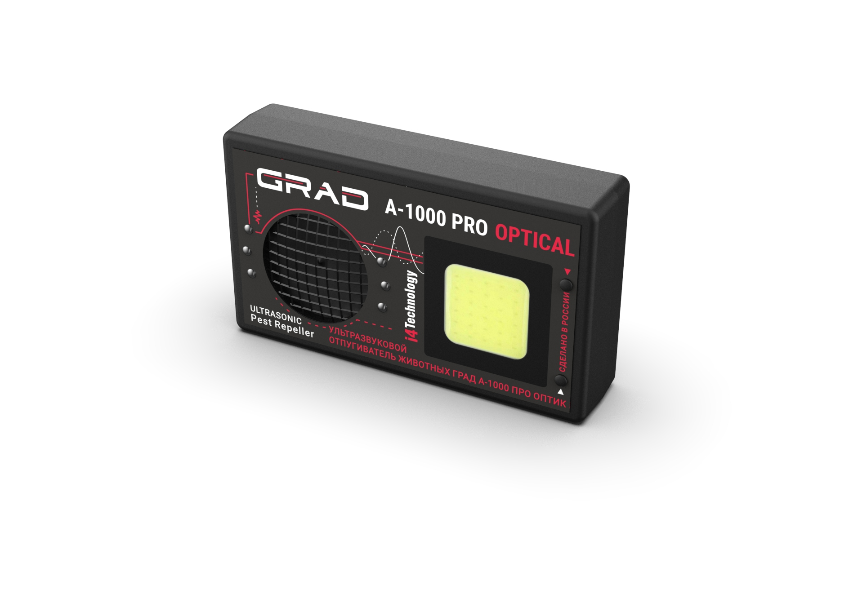
Figure 1. Visual appearance of the device

1.2.2. Dimensions….………………...…………...……...……………...109 х 65 х 25 mm (4.3 x 2.6 x 1 in)

1.2.3. Weight……………………..………………………..……………...………………….100 gr (0,22 lb)

1.2.4. Device shipping weight, including external power source………....……….………….470 gr (1,03 lb)

1.2.5. DC supply voltage when operating from an external power supply………………….….…...12±0,5 V

1.2.6. Maximum current consumption by the device…….…………….……….…...……...less than 350 mA

1.2.7. Operating frequency range of emission…...……………………………………….…from 4 to 72 kHz

1.2.8. The directional pattern of emissions..………………………………….……………………….circular

1.2.9. Sound pressure level at a distance of 1 m from the device…….…………….………less than 110 dB

1.2.10. Maximum protection area covered by emission ..…………….….…………………………...1000 m²

1.2.11. Number of acoustic modes……………….......……….……………………………….......................2

– mode 1 – the most effective deterrence mode (sound frequency waves and ultrasound)
– mode 2 – ultrasonic (silent) deterrence mode

1.2.12. Number of light modes………......……….……………………………….............…………............3

– mode 1 – the most effective deterrence mode (LED matrix with stroboscopic effect)
– mode 2 – ultra-bright LEDs
– mode 3 – faint flicker (this mode is not intended to deter and is used to monitor the device's operation in silent mode)

1.3. Device components

1.3.1. Device components and package contents are shown in Table 1.

Table 1
№ | Description | Quantity | Comments
1 | Ultrasonic pest repeller  «GRAD А-1000 PRO OPTICAL» | 1
2 | External power supply unit | 1
3 | Cardboard box | 1
4 | User manual | 1

1.3.2. Location of repeller’s main parts is shown in Figure 2.
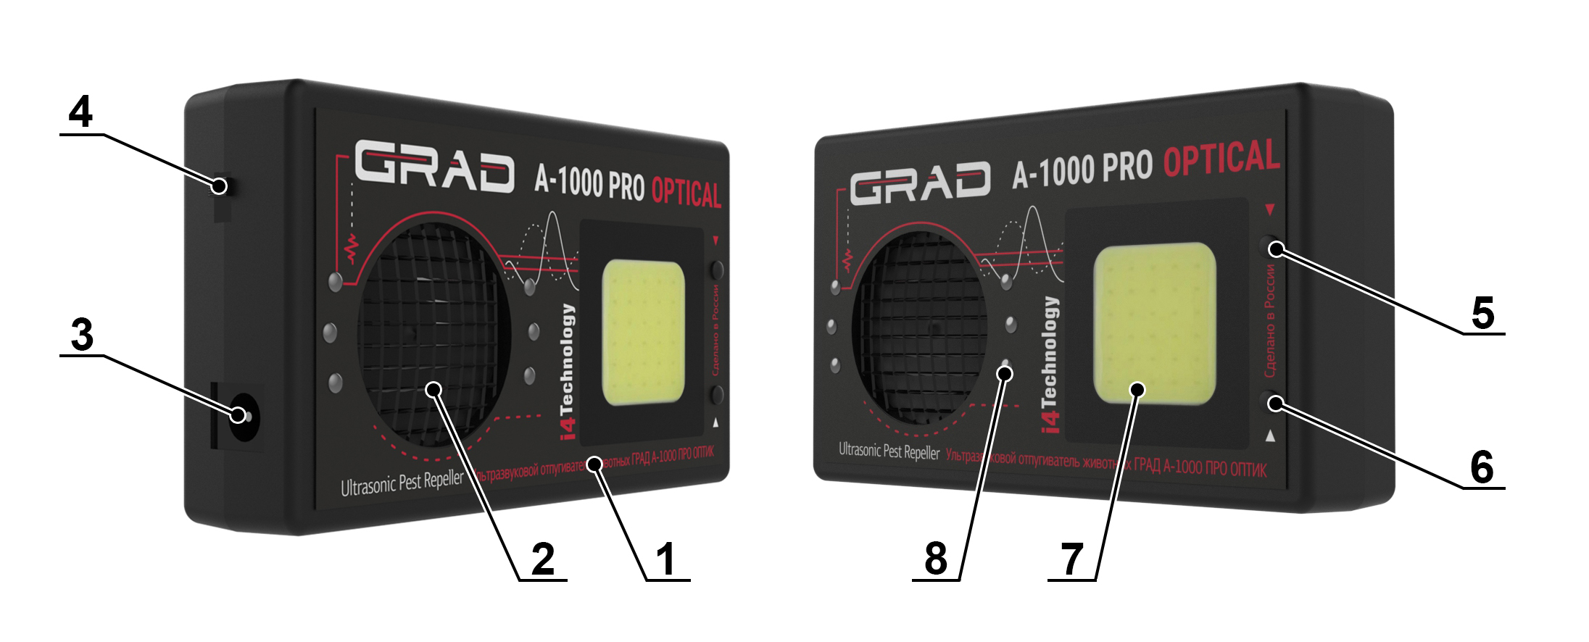

Figure 2 – Components assembly

The device consists of a housing (item 1) made of impact-resistant ABS plastic, with:
– Ultrasonic transducer, item 2
– Socket for connecting an external power supply, item 3
– Power button, item 4
– Sound mode selection button, item 5
– Light mode selection button, item 6
– LED matrix, item 7
– LEDs, item 8

1.4. Structure and functioning

1.4.1. The principle of operation of the device is based on rodents' intolerance to the emissions generated by the device in the sonic and ultrasonic ranges. The unique algorithm ensures an increase of the protected area while maintaining an emission level safe for humans. The constant change in emission parameters eliminates the habituation of animals to the device’s operation. The efficiency of the device is significantly increased by using two optical deterrence modes with a built-in LED matrix and ultra-bright LEDs with a specific wavelength.

1.4.2. The device runs under command of microcontroller with embedded software.

1.4.3. The device is powered by an external source with an output DC voltage 12 V.
The polarity of the power jack is shown in Figure 3.

Figure 3 – Polarity of jack for external power source.

2. INTENDED USE

2.1. Operating restrictions

2.1.1. Do not keep the device switched on near human ears, as it can lead to headaches and temporary hearing loss.

2.1.2. The device uses bright light sources in its operation. Do not direct the light into people’s eyes!

2.2. Device usage

2.2.1. Press the power button, item 4 (Figure 2) to turn on the device. The desired sound mode is selected by pressing the button, item 5, sequentially, as well as the light mode is selected by pressing the button, item 6.

2.2.2. For an effective expelling effect, it is important to choose the right place for the device. Please consider the following factors:
– Ultrasonic waves reflect from hard objects and are absorbed by soft materials
– Ultrasonic waves do not penetrate walls or partitions
– Maximum effectiveness is achieved by installed the device at 2-2.3 ft (60-70 cm) above the ground (floor).

2.2.3. When fighting mice and rats, the result of indoor use (complete disappearance of rodents) can be observed after 14 days of continuous operation of the device.

3. MAINTENANCE

3.1. Maintenance consists of cleaning the outer surface of the product as it becomes dirty.

3.2. Current repair. Types of possible malfunctions

Typical problems and possible solutions are specified in Table 2.

Table 2
Problem | Possible reasons | Possible solution
When the device is turned on, the LED does not light up and there is no audible sound. | No external power supply is connected | Connect an external power supply
 | Device is defective | Take the device to service center

4. PACKAGING, STORAGE AND TRANSPORTATION
Each device is supplied in individual packaging according to the supply contents as indicated in Table 1.
Device shattering in the box is not allowed.
Packed devices are placed into shipping containers – corrugated fiberboard boxes.
Packaged devices can be transported by vehicle or railway in covered cars or containers, or by air in pressurized compartments.
During transportation, packaged devices must be protected from direct exposure to atmospheric precipitation and solar radiation.
Transportation conditions:
– Surrounding air temperature: from -50 to 50°С (58 to +55°F)
– Relative humidity up to 95 % at 25 °С (77°F)
– Atmospheric pressure from 84 up to 107 kPa (630-800 mmHg)
– Shock acceleration peak value is up to 147 m/s2 (15 g), with a duration of shock acceleration 10 ... 15 ms
The requirements on warning signs must be strictly obeyed when loading and transporting.

5. ACCEPTANCE CERTIFICATE

Ultrasonic pest repeller «GRAD А-1000 PRO OPTICAL»
Serial number ____________________
Manufacture date ____________________
Manufactured and accepted in accordance with the applicable technical documentation and validated.
Quality Department stamp ___________________

6. MANUFACTURER WARRANTY

6.1. The manufacturer guarantees that the device is manufactured in accordance to INTK.433523.021 RE provided the operation, storage and transportation conditions are observed. Conditions are specified in the operational documentation.

6.2. Effective device duration period – not less than 5 years.

6.3. Manufacturer warranty – 12 months from the date of purchase.

6.4. If the device fails during the warranty period, the supplier (manufacturer or companies providing maintenance services) should replace or repair it at their own expense.

6.5. Customer loses the right to obtain warranty service in the following cases:
– After warranty term expiration
– Violation of the operation, transportation and storage instructions
– Mechanical damages causing device failure after the purchase
– Manufacturer sealing is broken.

6.6. Repair and maintenance of devices with an expired warranty period is covered at the customer’s expense.
___________________________________________________________________________________________

Manufacturer reserves the right to amend or change the characteristics of the device, improving its consumer properties.

Manufacturer's technical support:
www.en.i4technology.ru
© Copyright i4 Technology LLC, 2005-2025.
All rights reserved.

Questions concerning the exchange after-sales service should be applied to the distributor that completed a sale.

