

“Grad А-650D”
rodent repeller
with a hybrid ultrasonic
system

User manual

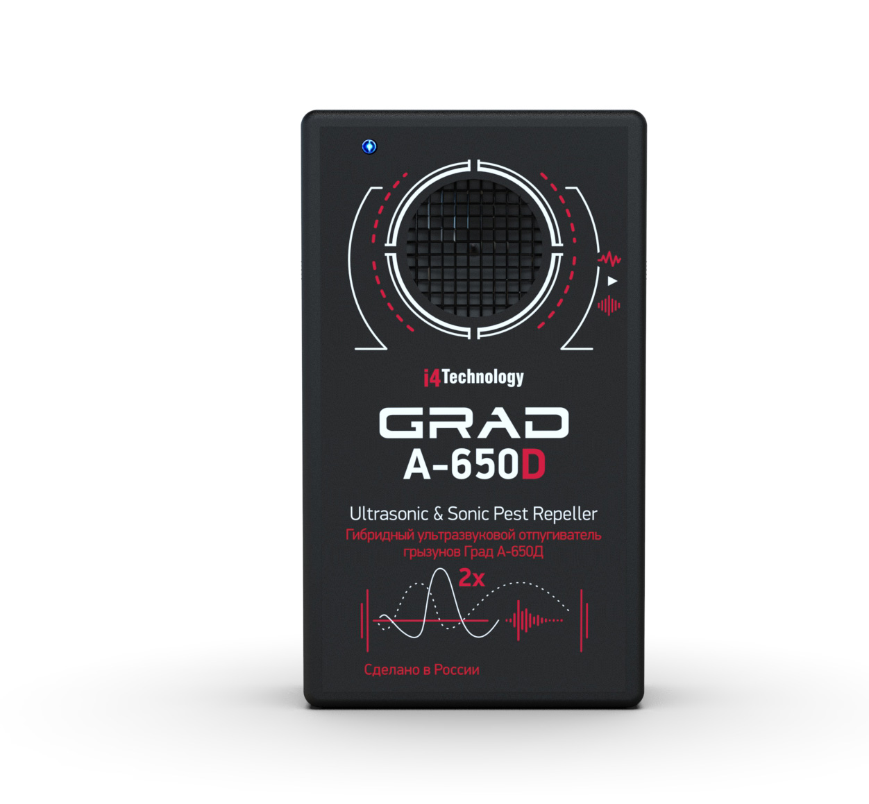

The User Manual includes key features, operating instructions (intended use, maintenance, repair, storage and transportation) of a rodent repeller with a hybrid ultrasonic system "Grad А-650D" (hereinafter - device).
The main distinguishing feature of the device is that it can operate in both hybrid (sound and ultrasonic) and silent (ultrasonic) mode.
Before using the device, please, carefully read the present User Manual.
Following the instructions, restrictions and guidelines contained in User Manual will extend the life of the device and allow you to use it most effectively.
WARNING! Before using, the device should be kept at room temperature for two hours after storing in a cold room or transporting in wintertime.

The manufacturer is not liable for damage caused by improper use or failure to comply with this User Manual.

- DEVICE DESCRIPTION AND OPERATION

1.1. Device application

1.1.1. This is a portable device designed to deter rodents (mice, rats) in garden areas and in enclosed spaces: warehouses, storages, domestic premises, etc.
Operating principle is based on rodents' intolerance of emissions generated by the device. Sonic and ultrasonic waves affect the nervous system of rodents, causing them to feel pain and discomfort. Rats and mice lose their ability to consume food and water and try to leave the room. At the same time, the device does not have a harmful effect on people and pets.
In comparison with other analogues, a distinctive feature of the device is that the parameters of the generated signal are constantly changing. At the same time, the repetition period of the sound pattern is more than 60 hours, which eliminates the habituation of rodents to these emissions, and also allows to install additional devices at any distance without the effect of "fading sound".
The device can be powered both from an external power supply unit and from batteries installed in it, which, in turn, allows the device to be used in places where it is not possible to connect to an AC network (for example, in the open space of a garden).

1.1.2. Device operating conditions:
– Surrounding air temperature ………………………………………..…...from -40 to +50^{О}С (-40 to +122^{О}F)
– Relative air humidity at 25^{О}С………………………………………………..……………………up to 98%
– Atmospheric pressure …………………from 66,6 kPa up to 106,6 kPa (from 500 mmHg up to 800 mmHg)

1.2. Technical specifications

1.2.1. Visual appearance of the device is shown in Figure 1.
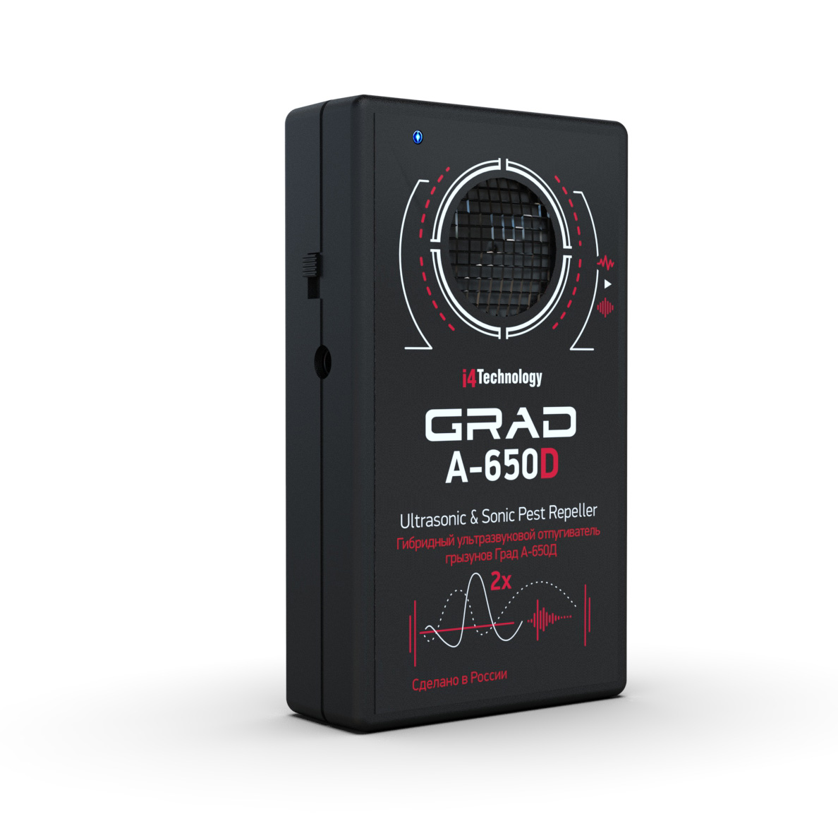

Figure 1. Visual appearance of the device

1.2.2. Dimensions……………………………………...……..………………109 х 65 х 25 mm (4.3 x 2.6 x 1 in)

1.2.3. Weight, including batteries………………………...………………………………………..120 gr (0.27 lb)

1.2.4. Device shipping weight, including external power source…………………………......…...470 gr (1.03 lb)

1.2.5. DC supply voltage (3 batteries ААА)……………………………………………………….….…… 4,5 V

1.2.6. DC supply voltage when operating from an external power supply……………………..….from 5 to 15 V

1.2.7. Maximum current consumption by the device
batteries ………….…………….……………………………………....………10 mA
external power source.…….…………….………………..….…..…………..…13 mA

1.2.8. Operating frequency range of emission in hybrid mode………………………...…..……from 4 to 40 kHz

1.2.9. Operating frequency range of emission in ultrasonic mode……………..……...……….from 20 to 40 kHz

1.2.10. The directional pattern of emissions...…………………………………….………………………. circular

1.2.11. Sound pressure level at a distance of 1 m from the device…….………………………...………. 110 dB*
(maximum safe level of emission for human according to SanPin 2.2./2.1.8.582-96)

1.2.12. Maximum protection area covered by emission ...……………….….……………………..……..650 m2

1.3. Device components

1.3.1. Device components and supplied package are shown in Table 1.

Table 1
№ | Description | Quantity | Comments
1 | Rodent repeller with hybrid ultrasonic system "Grad А-650D" | 1
2 | External power supply unit | 1
3 | Cardboard box | 1
4 | User manual | 1

1.3.2. Location of repeller’s main parts is shown in Figure 2.

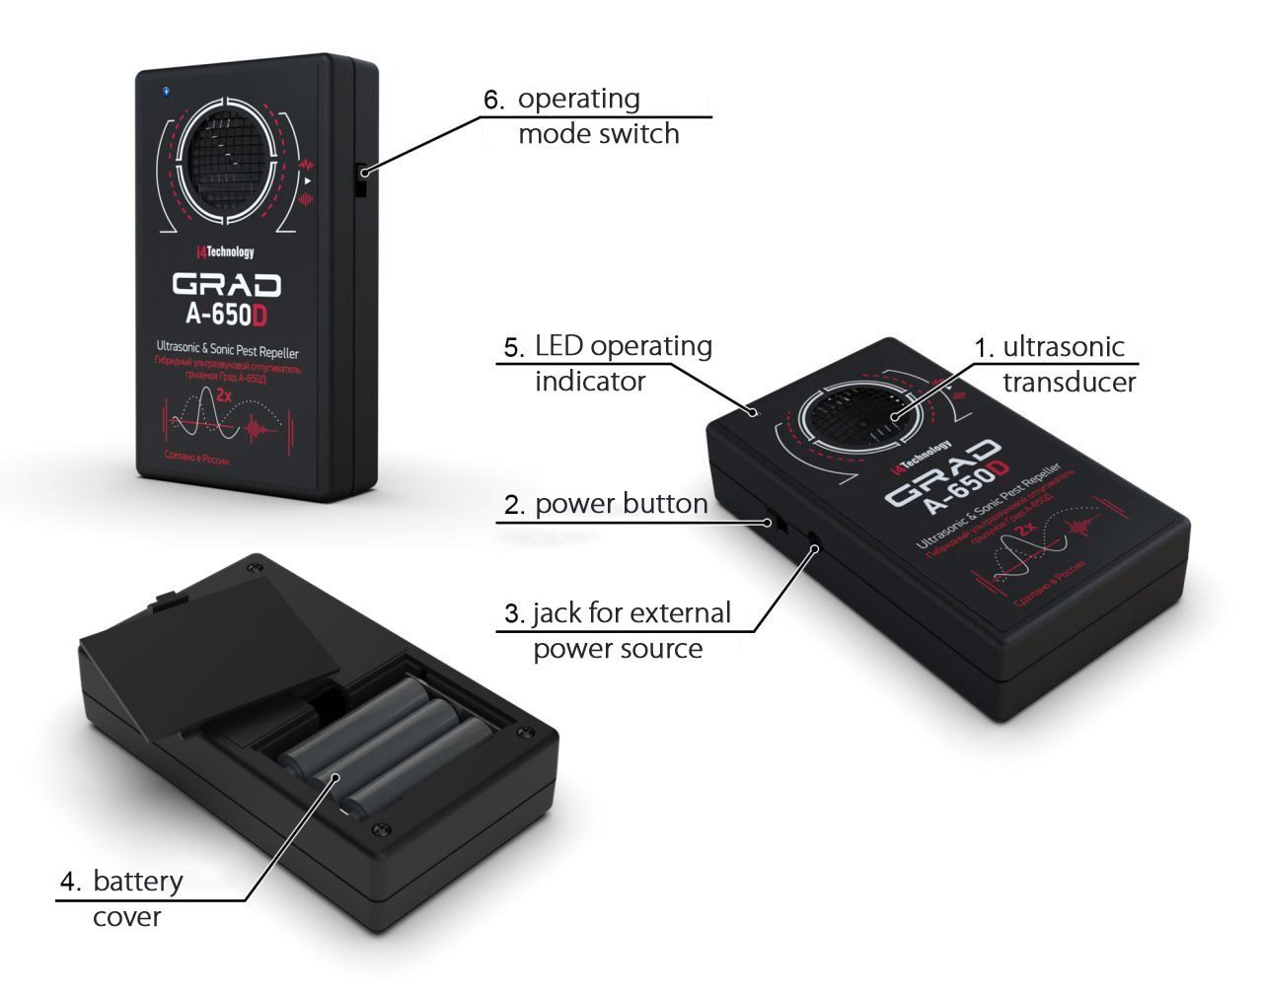

Figure 2 – Components assembly

The device consists of a housing made of impact-resistant ABS plastic, with:
– Ultrasonic transducer, item 1
– Power button, item 2
– Jack for external power source, item 3
– Battery compartment, item 4
– LED operating mode indicator, item 5
– Operating mode switch, item 6

1.4. Structure and functioning

1.4.1. The principle of operation of the device is based on rodents' intolerance to the emissions generated by the device in the sonic and ultrasonic ranges. The constant change in radiation parameters eliminates the habituation of rodents to the device’s action.

1.4.2. The device runs under command of microcontroller with embedded software.

1.4.3. The device is powered by 3 batteries type ААА and by an external source with an output DC voltage 5-15V.
There is a correct installation diagram at the bottom of the battery compartment.
The external power source is plugged in through a jack, item 3.
The polarity of the power jack is shown in Figure 3.

Figure 3 – Polarity of jack for external power source.

2. INTENDED USE

2.1. Operating restrictions

2.1.1. Do not keep the device switched on near human ears, as it can lead to headaches and temporary hearing loss.

2.2. Device usage

2.2.1. Press the power button, item 2 (Figure 2) to turn on the device. The product immediately starts emitting sound or ultrasonic signals (depending on the selected operating mode). The operating mode is selected using the switch, item 6. In silent (ultrasonic) mode, the LED item 5 lights up periodically.

2.2.2. For an effective expelling effect, it is important to choose the right place for the device. Please consider the following factors:
– Ultrasonic waves reflect from solid materials and are absorbed by soft materials
– Ultrasonic waves do not pass through walls or partitions
– Maximum effective device operation is achieved by placing it at 60-70 cm above the ground (floor).

2.2.3. The result of device usage in closed space is complete disappearance of pests after 14 hours
of continuous operation.

3. MAINTENANCE

3.1. Maintenance consists of replacing failed batteries or charging batteries, as well as cleaning the outer surface of the product as it becomes dirty.

3.2. Current repair. Types of possible malfunctions

Typical problems and possible solutions are specified in Table 2.

Table 2
Problem | Possible reasons | Possible solution
When the device is turned on, the LED does not light up and there is no audible sound. | Batteries are dead | Replace batteries
 | An external power supply connector is inserted | Turn on the external power supply or remove the connector
 | Device is defective | Take the device to service center

4. PACKAGING, STORAGE AND TRANSPORTATION
Each device is supplied in individual packaging according to the supply contents as indicated in Table 1.
Device moving in the package is not allowed.
Packed devices are placed into shipping containers – a corrugated fiberboard box.
Packaged devices can be transported by vehicle or railway in covered cars or containers, by air in pressurized compartments.
During transportation, packaged devices must be protected from direct exposure to atmospheric precipitation and solar radiation.
Transportation conditions:
– Surrounding air temperature: from -50 to 50°С (58 to +55°F)
– Relative humidity up to 95 % at 25 °С (77°F)
– Atmospheric pressure from 84 up to 107 kPa (630-800 mmHg)
– Shock acceleration peak value is up to 147 m/s2 (15 g), with a duration of shock acceleration 10 ... 15 ms
The requirements on warning signs must be strictly obeyed when loading and transportation.

5. ACCEPTANCE CERTIFICATE

Rodent repeller with a hybrid ultrasonic system "Grad А-650D"
Serial number ____________________
Manufacture date ____________________
Manufactured and accepted in accordance with the applicable technical documentation and validated.
Quality Department stamp ___________________

6. MANUFACTURER WARRANTY

6.1. The manufacturer guarantees that the device is manufactured in accordance to INTK.433523.021 RE provided the operation, storage and transportation conditions are observed. Conditions are specified in the operational documentation.

6.2. Effective device duration period – not less than 5 years.

6.3. Manufacturer warranty – 12 months from the date of purchase.

6.4. If the device fails during the warranty period, the supplier (manufacturer or companies providing maintenance services) should replace or repair it at their own expense.

6.5. Customer loses the right to obtain warranty service in the following cases:
– After warranty term expiration
– Violation of the operation, transportation and storage instructions
– Mechanical damages causing device failure after the purchase
– Manufacturer sealing is broken.

6.6. Repair and maintenance of devices with an expired warranty period is covered at the customer’s expense.
___________________________________________________________________________________________

Manufacturer reserves the right to amend or change the characteristics of the device, improving its consumer properties.

Manufacturer's technical support:
www.en.i4technology.ru
© Copyright i4 Technology LLC, 2005-2013.
All rights reserved.

Questions concerning the exchange after-sales service should be applied to the distributor that completed a sale. Distributor contacts are specified in the warranty card.

